***Nature***

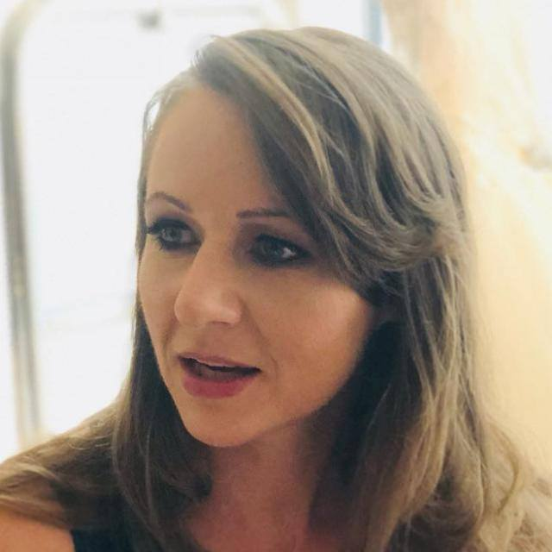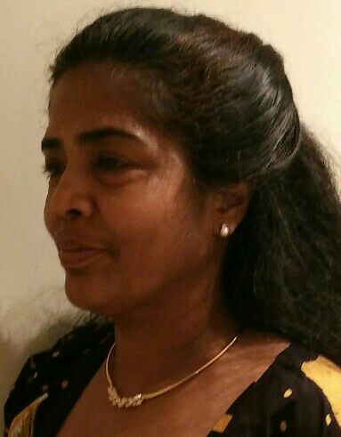*I am a person, who loves nature and its ordinary miracles. I feel sad that the human race is going into wrong direction by destroying the nature for the short term goals. Our very survival is solely depends on natural resources be it trees, forests and water. When I am in Toastmasters, what better way to inspire audiences to take action than taking a topic which is close to my heart? So, my milestone Project10 speech of CC manual on November 19th had reflected this. I started with a quote which is very apt as people expect environmentalists and others to save not themselves.*

*The greatest threat to our planet is the belief that someone else will save it. By Robert Swan- Well, I admire the miracles of an ordinary day; do you? Twilight hues of sunrise & sunset, lush greenery, thunderous waterfall, Dew in a plant, butterfly coming out of cocoon, bud blossoming as flower, drops of rain, colourful rainbow and millions more. I love… the nature, when you love something you want to take care, not to misuse or destroy, right.*

Here I am, attending one of my first meetings, listening the last speaker of the meeting unfolding her passion. She is speaking deeply from the heart, her experience, emitting authentic truth of her being. My ears are tuned to her warm accent. How lo ng will it take me to integrate mind, body and voice to deliver any speech with such an ease and devotion?

***I threw a question to audience whether I have the privilege to enlist them as my eco warriors to preserve ‘miracles of an ordinary day’.*** *Do you belief that the “Knowledge is of no value unless you put it into practice”? We all know that we need to protect our beautiful planet as the clock is ticking like a time bomb. How do you do it? Every one of you may be doing it in your small way but that is not enough. Many countries’ economies, including ours are going bad to worse due to the loss of forests because of short term goals. It is the time to wake up and if not, our future generation will hold us responsible. Do you recycle with lot of passion and if you do, you will understand how I feel when I see when we take our natural resources especially trees for granted? Trees properly placed around buildings can reduce air-conditioning needs. Do you know that deforestation is the main cause of carbon emissions?*

Glancing around the room, I see other people sitting in the audience, focused on the speaker’s views. She whispers loudly to make the content more dramatic and mysterious. I notice subtle reactions among members, their body is gently responding to her voice modulation, to idioms she’s using. What captures my attention is the spark in their eyes… so priceless nowadays, in the world where everyone out there is occupied by their own story, by technology, by worry. I realize that here, people come to life.

***I continued my journey after joining Emirates Environmental Group;***

*My family with our friends, for the past few years has recycled papers, saved 11 and planted 6 trees as a token of appreciation in UAE****.*** *Even though we had planted many, these trees are special as we can identify with our name****.*** *Imagine that we come after 20 years and see these 6 mature trees around 7 emirates & proudly show our future generation about how our small contribution is thriving and giving shelters to humans & other species so that they inspire & take home a beautiful message.*

Further down the line I find myself picturing families involved in a community goals. In global goals! Parents, children and the community working together to promote wellbeing of our planet. It has meaning. It can be fun! Ok, maybe I don’t have enough time to organize something big, maybe I can also plant a tree one day!

***I had re-iterated what should we do and ended up with my experience when we collect paper products from our friends and my dream.***

*I am sure, every one of you want your country to retain her natural beauty, thriving economy and long, healthy & happy life without stress & lifestyle diseases and hand over our beautiful planet intact to future generation and other species. Well, I admire the miracles of an ordinary day; love my fascinating planet hence I took the mantle to inspire many. During my paper recycling, even the kids and toddlers at time join and the kids are delighted and felt so proud of their achievement when I thanked them and gave a bear hug. A beautiful quote which had touched my heart, “Don’t be afraid to give up the good for the great”. You all are such amazing people with so much of potential to change the world as a paradise for you and your future generation. Come along with me. We shall find peace. We shall hear chirping sounds, we shall see mature trees trying to reach the sky which is sparkling with diamonds.*

I left meeting overwhelmed and inspired, the speaker’s mottos and phrases kept running through my head. ‘World as a paradise, miracles of an ordinary day, give up the good for the great’.

Later that night I wondered - what was the magic of this actual positive ambience? The very same energy that makes me feel that I can move mountains. What was the secret of the members of various social classes, backgrounds and age groups, gathered together to think big and to take action?

Maybe it was a matter of focus or matter of like – minded thinking or interest that is contagious, spirit that fuels confidence and creates excitement.

I singed to Toastmasters because I wanted to improve communication and learn how to become a leader. However, it seems to offer far more than skills place to grow with enthusiasm and passion. And passion is that very secret of toastmasters, the spark in the eye.

**TM Agata & TM Varatha**

**Greens Dubai Toastmasters Club**

**Runners Up - Duo Writing Competition by Division F**

